Specification
  - Extrusion: SQUARE 45
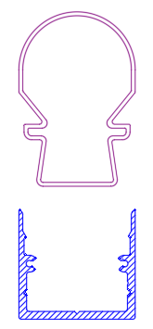

- The extrusion shall be made of aluminum alloy EN AW 6060 T66.
- The extrusion shall be available in following surface finishes:
  - Blank
  - Anodized natural (thickness 15µm)
  - Anodized black (thickness 15µm)
  - Coated with polyester powder-coating in all standard RAL-colors
- The extrusion shall have following dimensions: 45mm x 42mm.
- The extrusion shall be available in lengths up to 6m.
- The extrusion shall be compatible with an extruded PMMA cover.
- The extrusion shall have a compatible fully closed endcap.

